Introduction
There are many reasons why one might want to track objects around a room. While many mechanisms for doing such a thing exist, most are expensive and require complex dedicated hardware. My project will involve determining the practicality of tracking a microphone around the room by measuring time taken for sound to arrive from two speakers with known positions. This will give two possible positions on a 2d plane, but we can discard one and display the other based on its side of the line between the speakers.
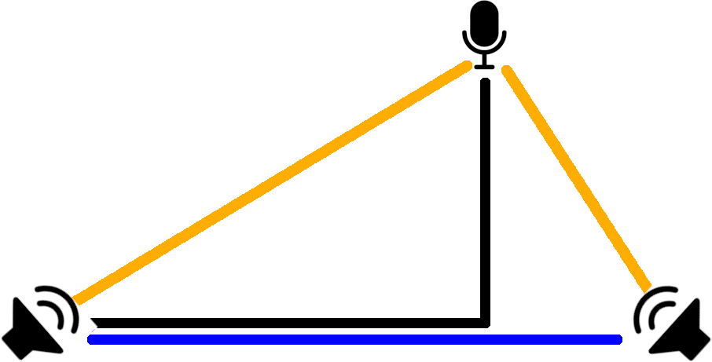
In this diagram we can see the principles the system will use. The distance between the speakers and the microphone is measured. Then, with the bottom left speaker as the reference (0,0) point we do some trigonometry to find the position of the microphone.
There are several potential issues with this already:
- How will the program be designed to accomplish the multiple tasks it must do at once in real-time without other loads on the machine impacting tracking?
- Will the FFT give us fast enough detection of whatever frequencies we use?
- What workable frequencies are there? The minimum is the limit of human hearing, but how easy is it to detect ultrasound with python/librosa? The max is 22khz because we have a sample rate of 44khz and nyquist-shannon theorem etc
- Will multipathing/echo be an issue? Testing suggests probably not at a rate of one fix per second, but higher may be a problem.
- If we do use ultrasound, will it cause harm to people’s hearing?
- Should I transmit one frequency twice or two frequencies at once to get two distances?
A proof of concept in Audacity at 6khz reveals that the system should be possible: here the delay between transmitted frequency at the top and received at the bottom is visible, despite only being 1ms (35cm). The FFT makes it easy to pick out the frequency we want from under the noise, rather than stopping the timer based on amplitude.
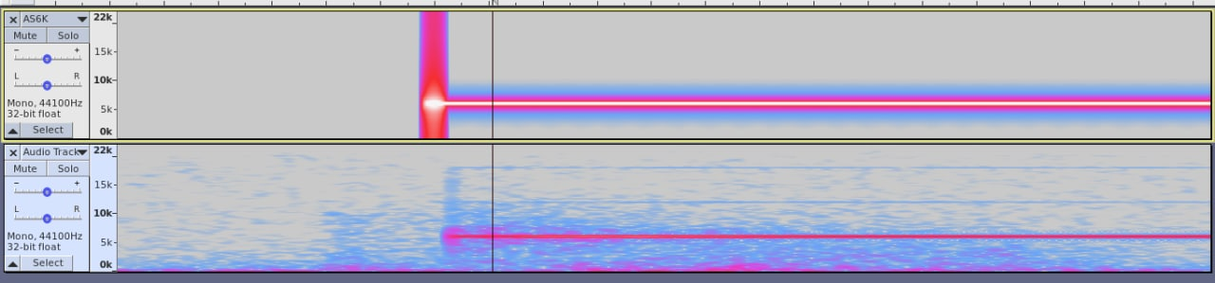
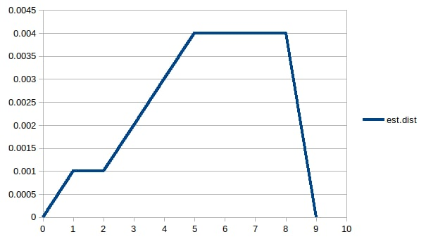
Further testing reveals that if I move the microphone away from the speaker, the delay does in fact increase. Y-axis here is seconds to receive the ping not distance, sorry. X axis is the time since I started the testing and you can see that I moved the microphone away from and then back to the machine.
My first idea for implementing it would be that the program has two main loops:
1) The loop that sends pings on alternating left and right channels and records the time the pings occurred
2) The loop that spins in a circle watching the FFT for said pings, and when it detects one it times it, waits for another ping for the other channel, does some trigonometry and redraws the content of the terminal in which the program lives, which will look something like this:
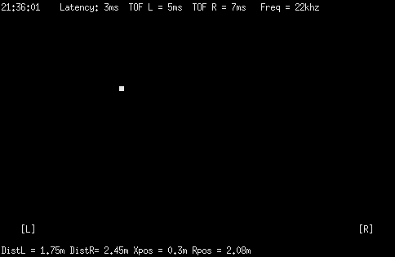

I’ve also written out a first attempt at the relevant trigonometry here:
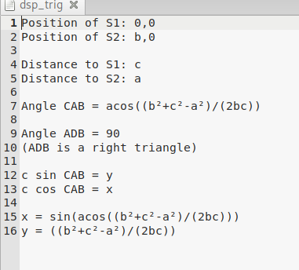

… I need to check that’s right before I use it for anything.

The first problem I ran into was actually getting it to ping reliably. You see, the obvious solution to ping on every second is:
via (https://stackoverflow.com/questions/51389691/how-can-i-do-a-precise-metronome)
while True:
play (ping_for_one_fifth_of_a_second.wav) # blocking play
sleep(0.8s)
This obvious solution will drift out of sync over time because, per the python docs:
The actual suspension time may be less than that requested because any caught signal will terminate the sleep() following execution of that signal’s catching routine. Also, the suspension time may be longer than requested by an arbitrary amount because of the scheduling of other activity in the system.
Unless version of python newer than 3.5 in which case it can only ever be longer than requested.

Another solution is this via the same stackoverflow thread:
while True:
play (ping_for_one_fifth_of_a_second.wav) # blocking play
t = (floor(current time) + 1 second) - current_time
sleep(t)
This will compensate for drift over from the system’s local time, which is nice, but you’ll still get jitter on each individual beep.
An improvement on this proposed by Moritz Uehling would be to plan to sleep until just before the time you need to ping and then busy wait in a while loop for the rest of the time. This is computationally expensive, however, so we are going to make pulseaudio do the beeping for us for the moment.
Here’s how that’s done: The soundcard essentially has a buffer of audio samples it plays at a given rate, so if we keep feeding it samples at a rate that averages out to be 1 second of samples in per second of sample played, it won’t run out of sound to play and there will be no drift from the rate of 1 beep/second. However, we won’t be able to know for certain when each beep happens, annoyingly.
So first I tried to throw five seconds worth of samples at the soundcard using
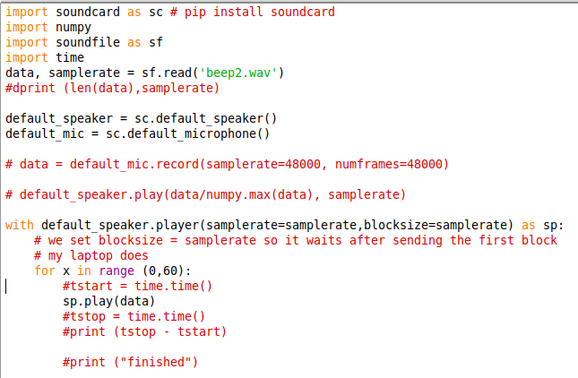
And it immediately became clear that actually sp.play was a blocking call which implied no buffering was happening and the timing was going to be bad.
Uh, right?
So we went looking into the code of the soundcard library and found that this was what should be running in the background:
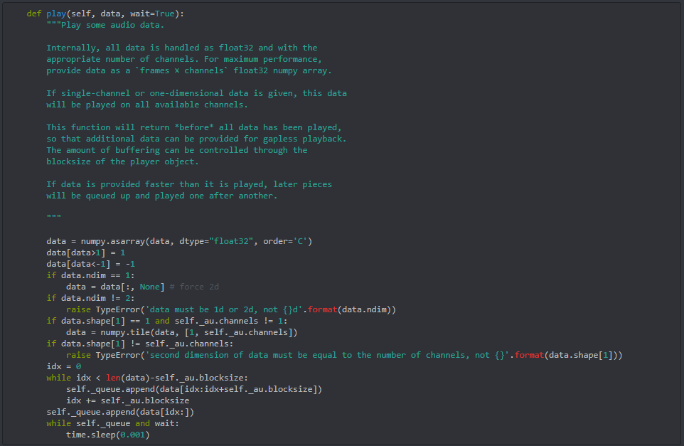
Excellent! We don’t need to do anything, then! The function will return before all the data has been played, so my current thing could work.
Uh, but that can’t be right, because the first call doesn’t seem to be blocking and returns after 0.001 seconds, but the second returns after 1.4s...
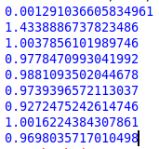

… Let’s disable wait, actually, just to see what happens.

… Ah, right, this is what we were running in the background actually, since we’re on linux rather than windows. The soundcard library is actually supposed to be cross-platform so different stuff occurs on different OSes.
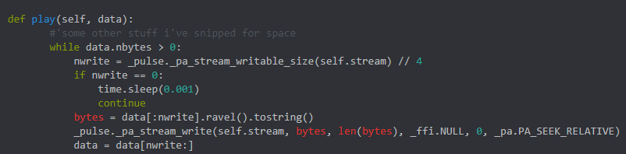
I’ve edited this down a bit so we can see what’s going on. What has actually occurred is that the function only blocks when pulseaudio’s buffer is full. That’s actually fairly reasonable.
So everything’s still going to work fine! Nice! That was an excellent four hours of troubleshooting code that already worked the whole time.
Still, we ought to test that the timing is right. I’ll plug the headphone jack of my laptop into my desktop and record the output.
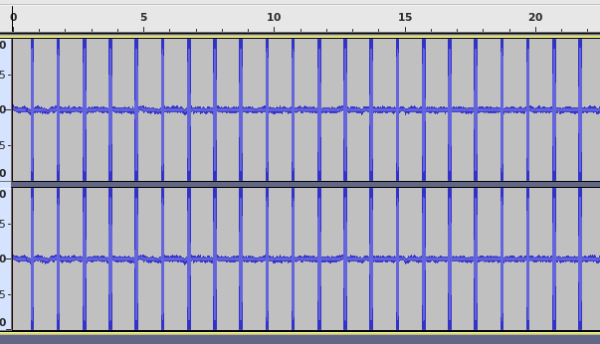
It’s clipping a bit, but we don’t care. Let’s line the start of the first beep up with 0s and look at the to see if there’s one beep every second.
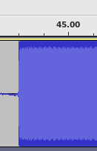

...Why is it faster???
- Pulseaudio skipping samples?
- My own stupidity, somehow, still?
- Hardware problem?
I then made audacity on my laptop generate a rhythm track at 60bpm and looked at the recording from my desktop’s microphone in jack. This rhythm track had a similar problem at about 1100 samples in a minute, and I think this is due to the clock of my desktop and laptop going at different speeds.
However, a recording of the audio output monitor also revealed pulses arriving early - this time the 59th pulse came 184 samples before it should have. That is… unfortunate, since it means my program is still somehow bad.

